**Web Server & App Server**1) Install nginx and run nginx on port number 81.  
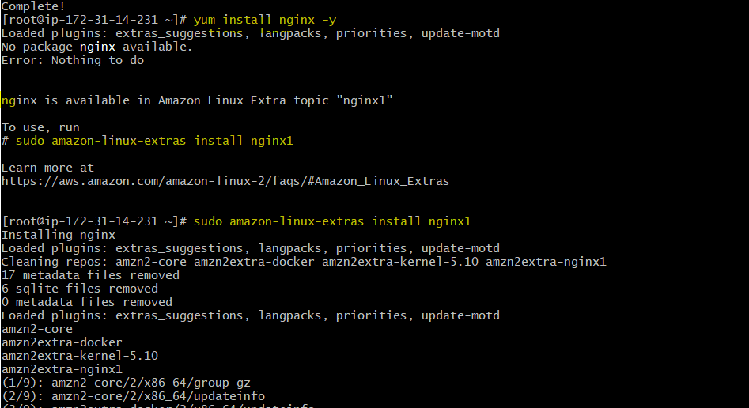  
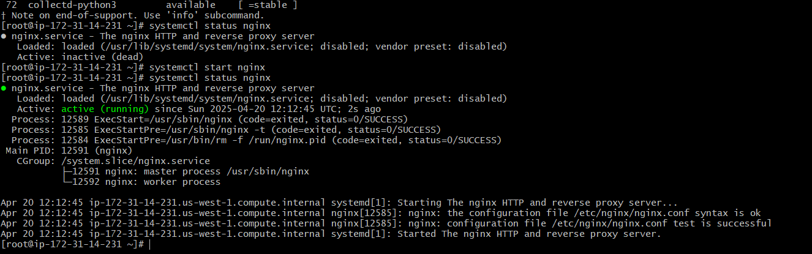  
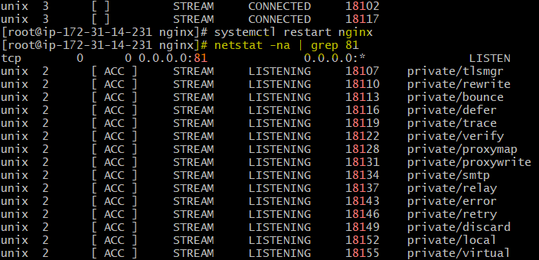  
  
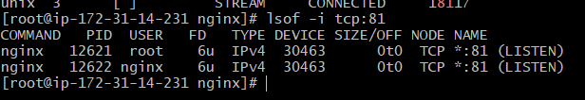  
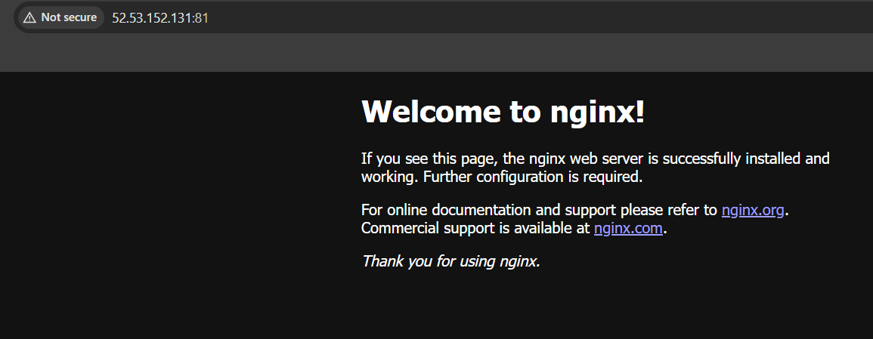  
  
2) Deploy a sample index.html file on nginx.

By editing index.html  
  
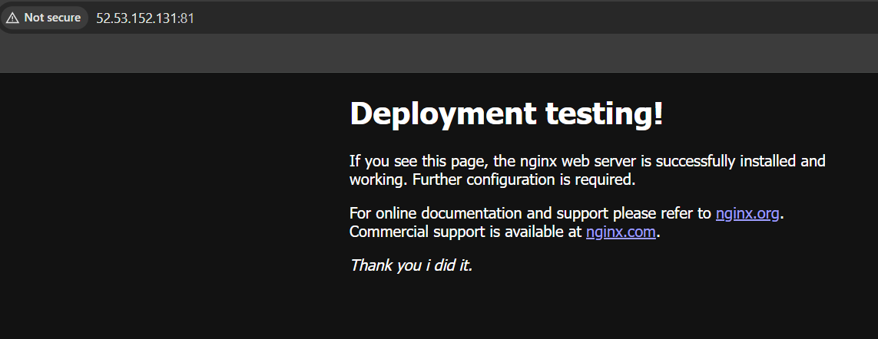

3) Install Apache and run Apache on port number 82  
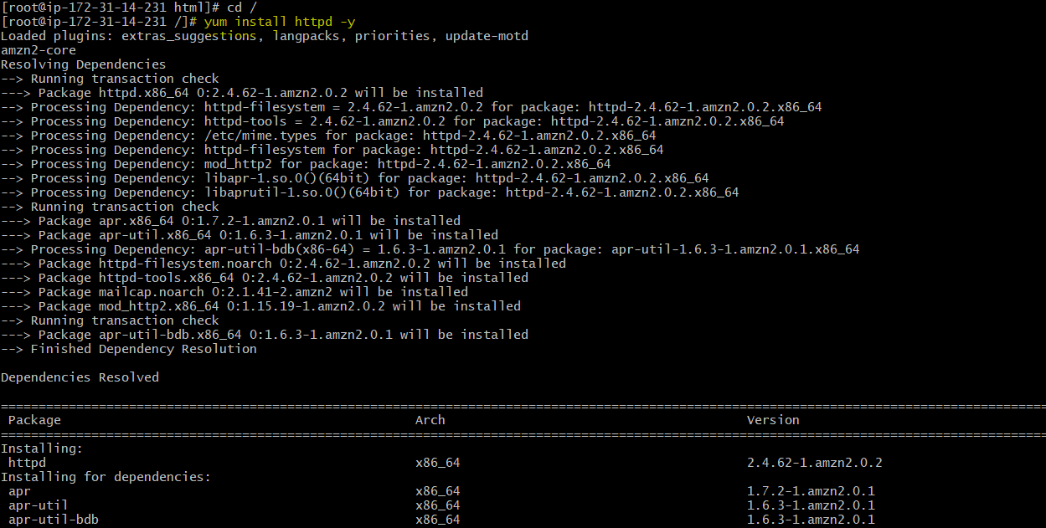  
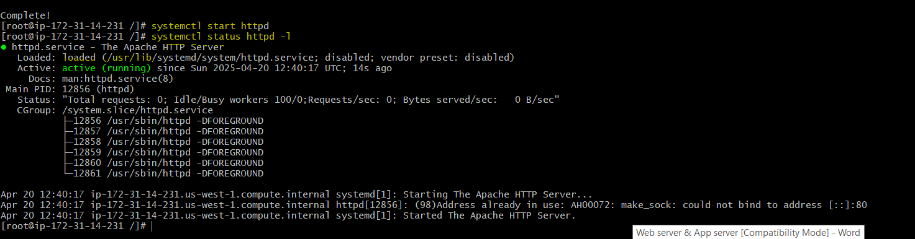  
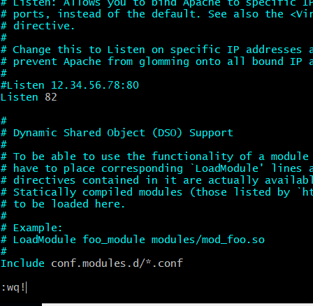  
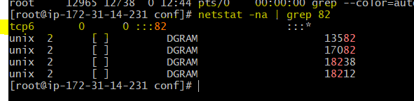  
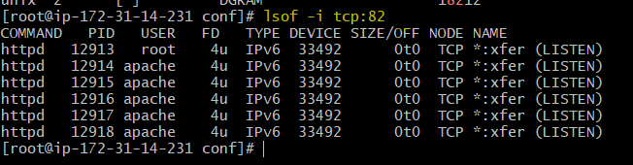  
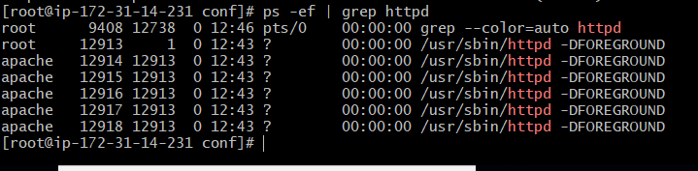  
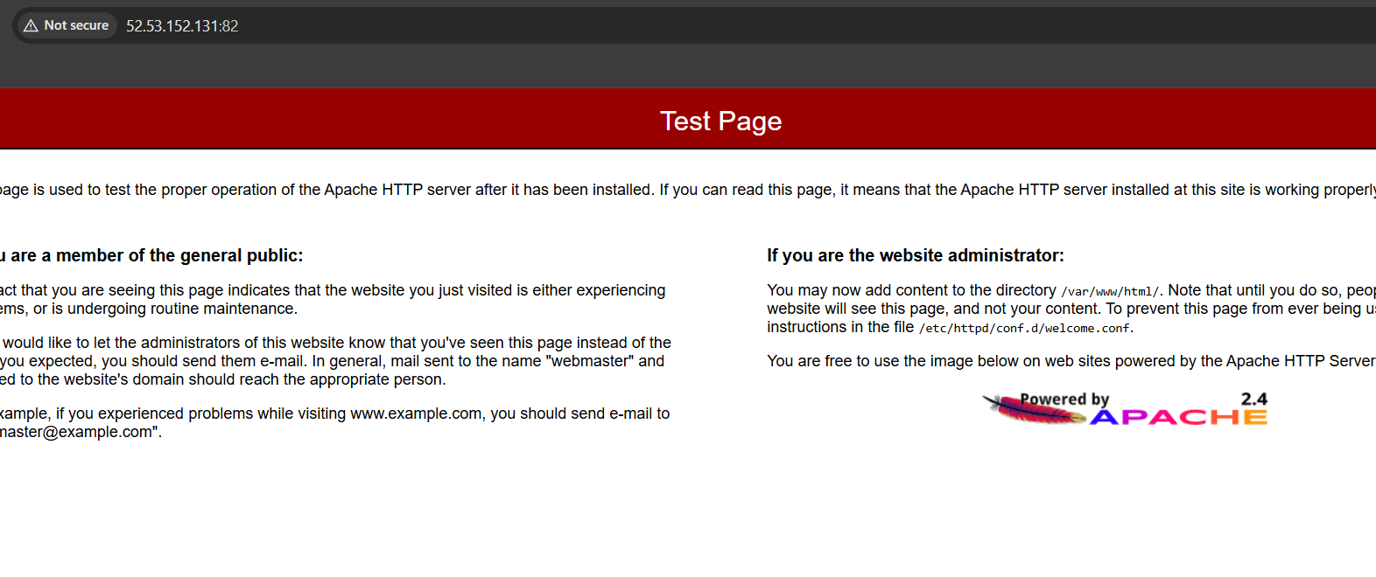

4) Deploy a sample index.html file on Apache.

By editing index.html  
  
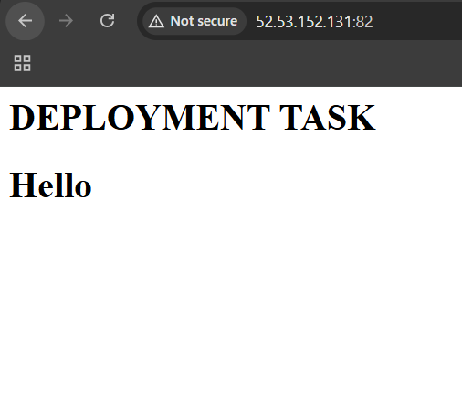  
5) Install Apache tomcat on port number 8082  
  
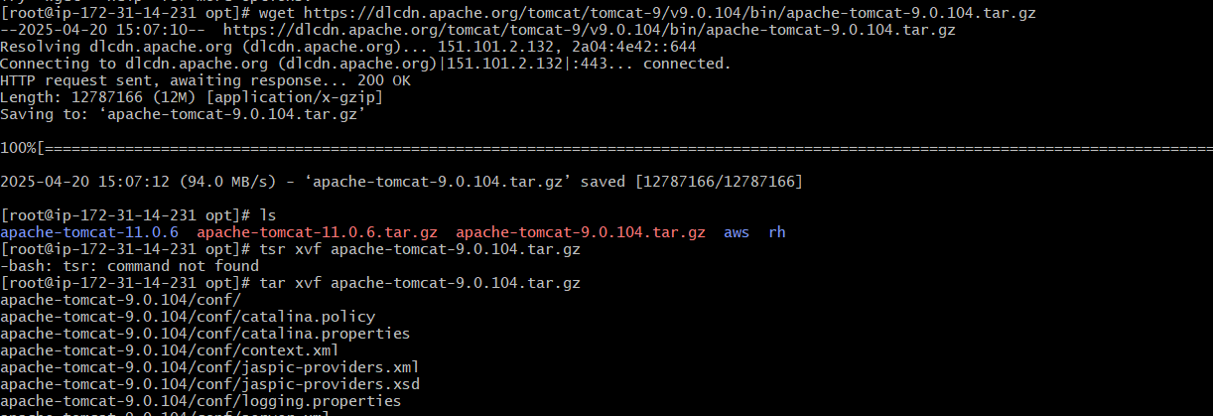  
  
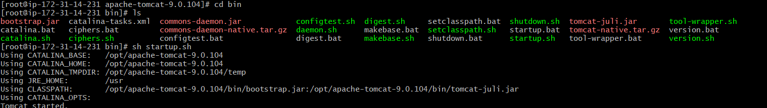  
  
  
  
  
  
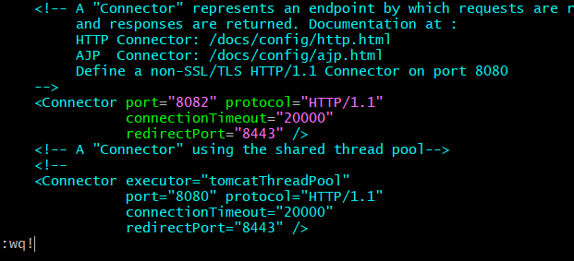  
  
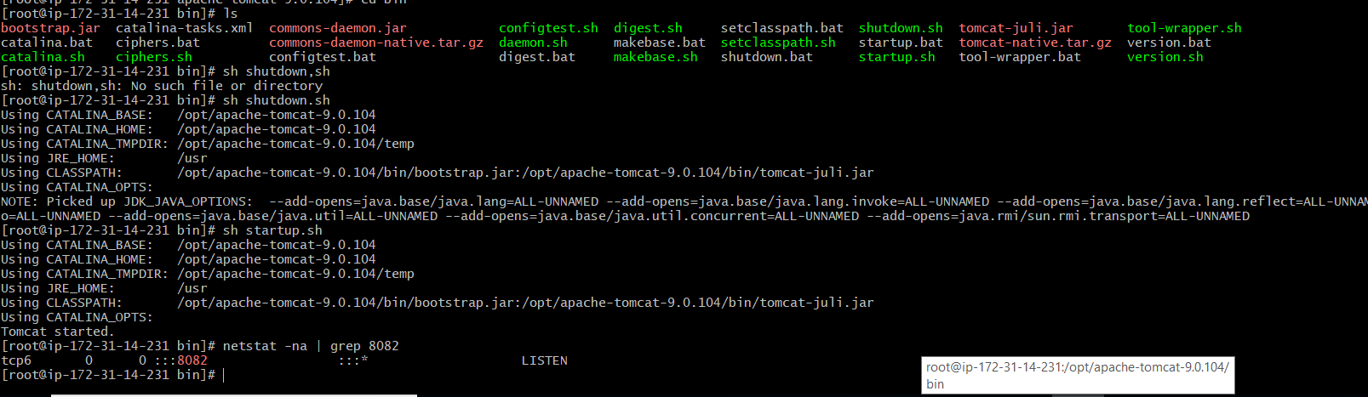

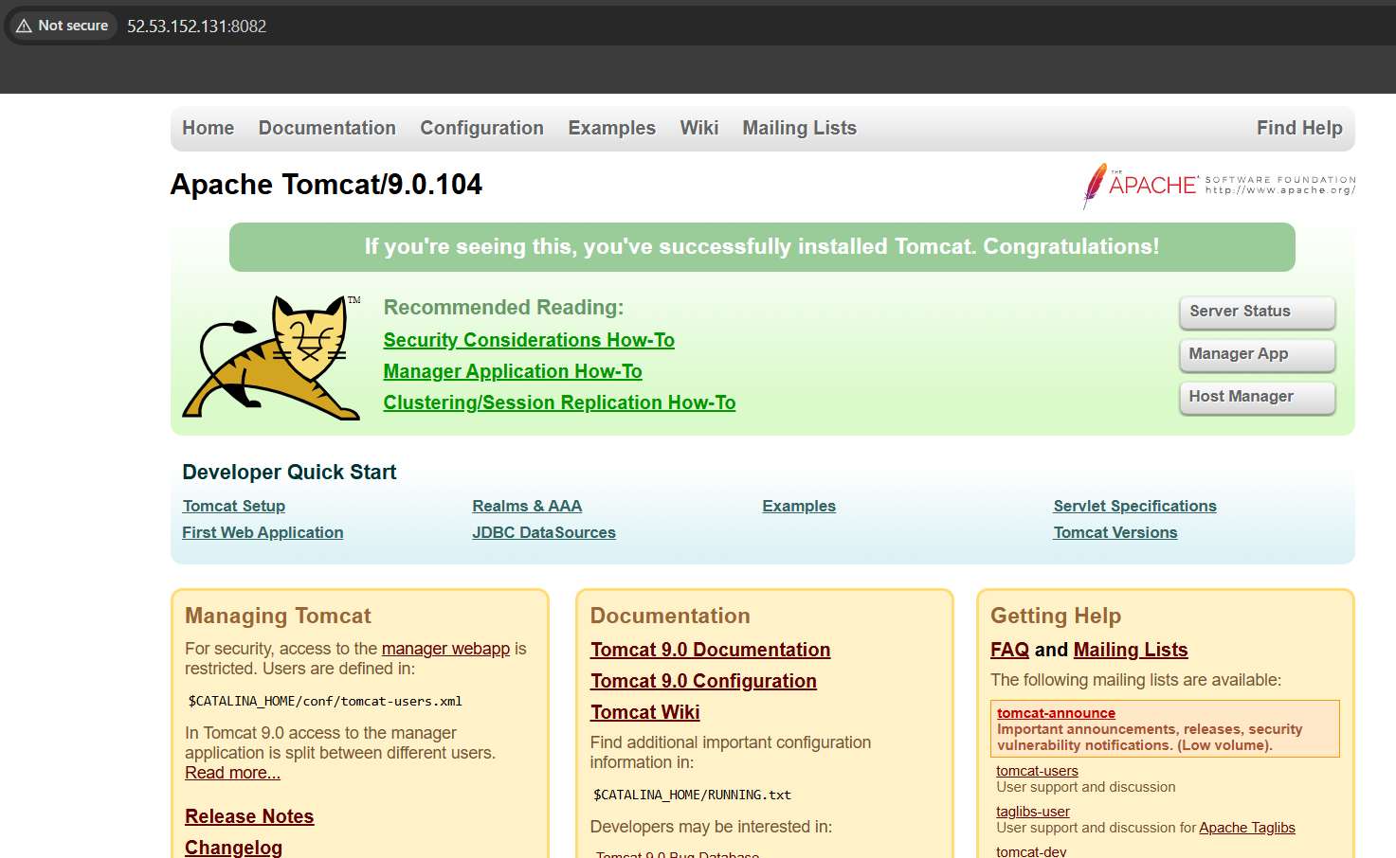

6) Deploy a sample app on webapps  
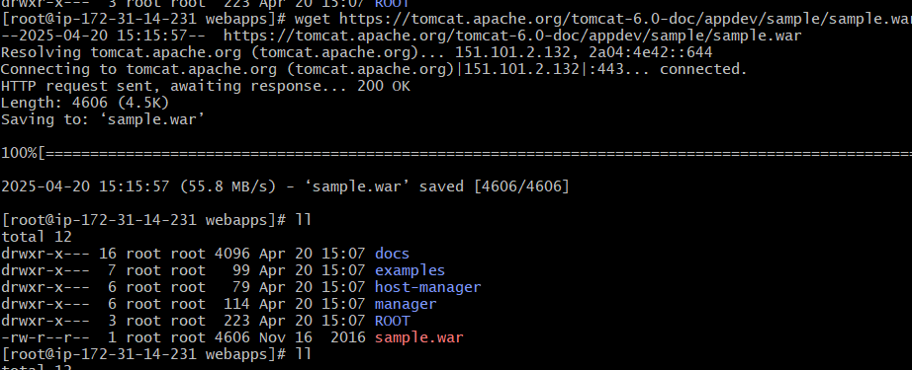  
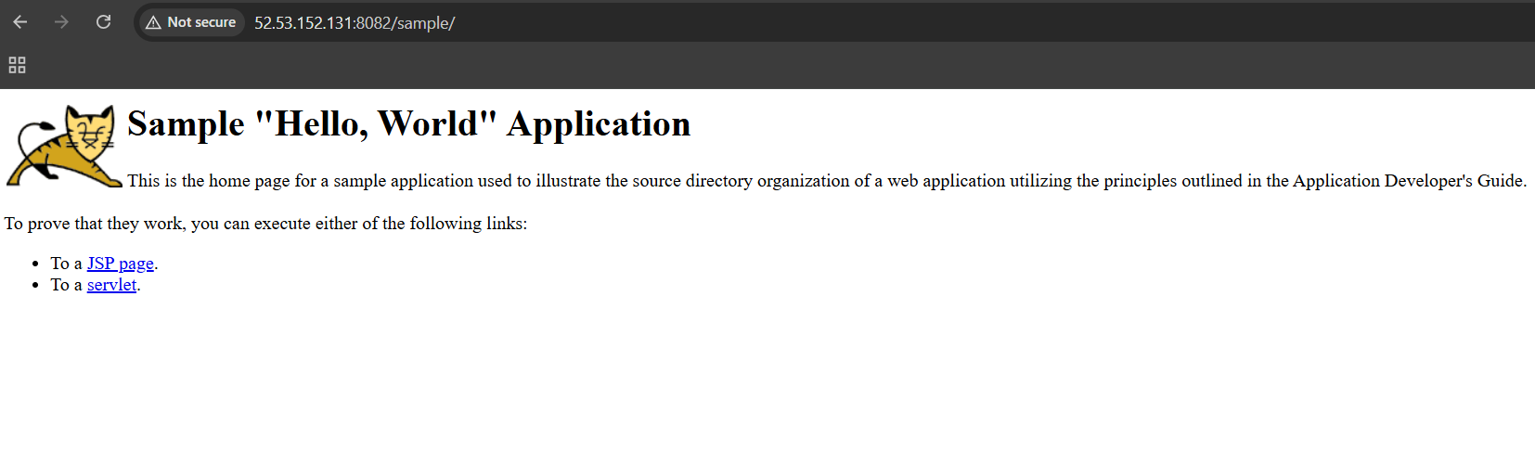  
  
  
7) Create a tomcat.service file for tomcat.  
  
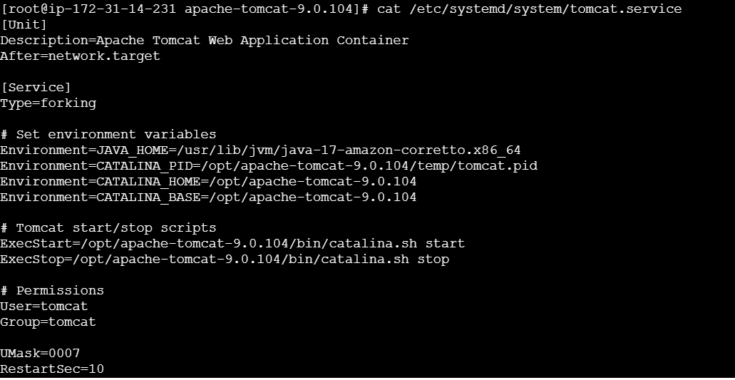  
  
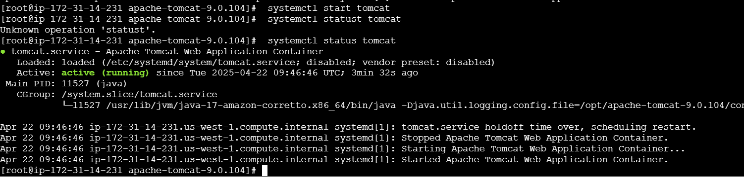  
  
  
8) Configure HA Proxy server

Create 3 instances  
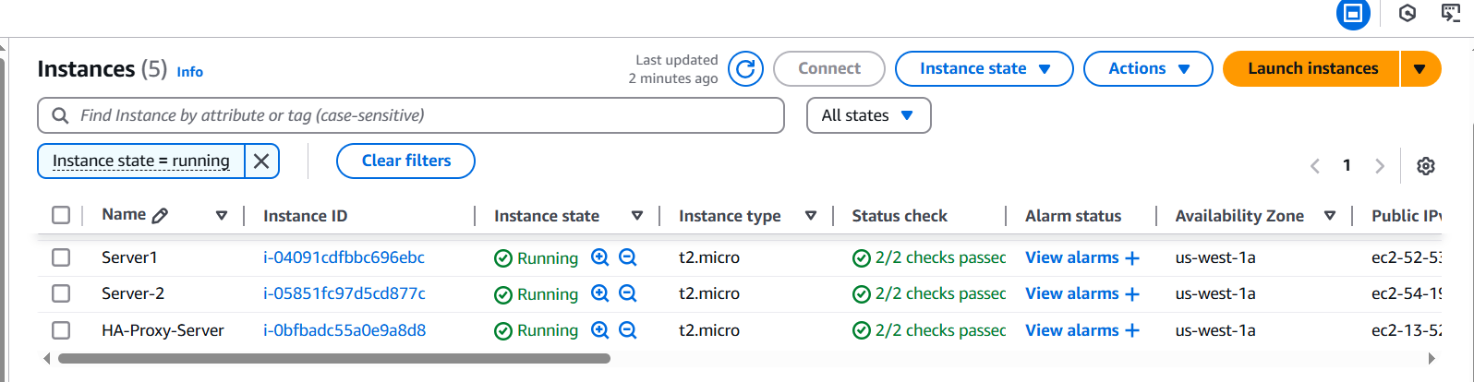  
  
Connected to **server1** in local machine, switching to root user and updating all installed packages  
  
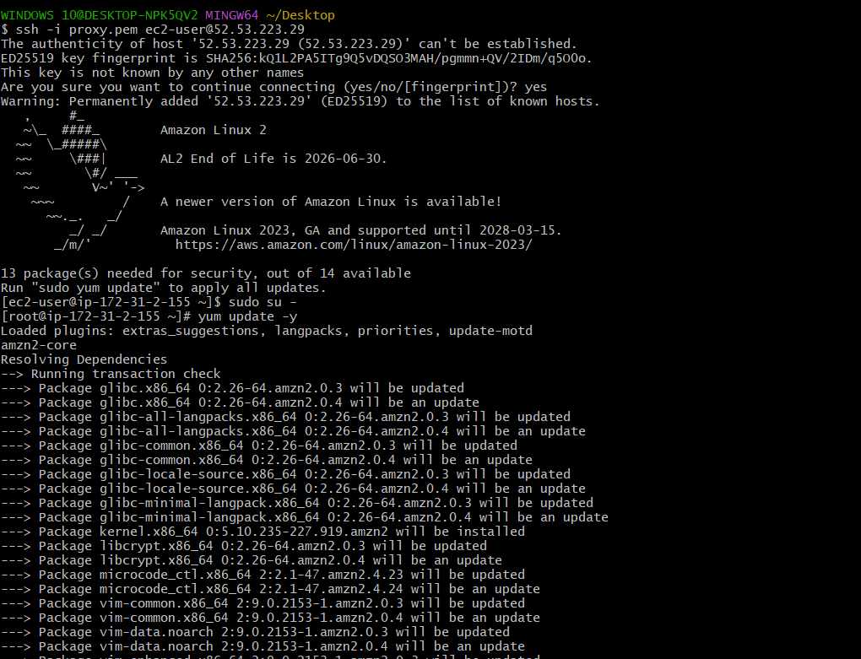

Installing web server httpd  
  
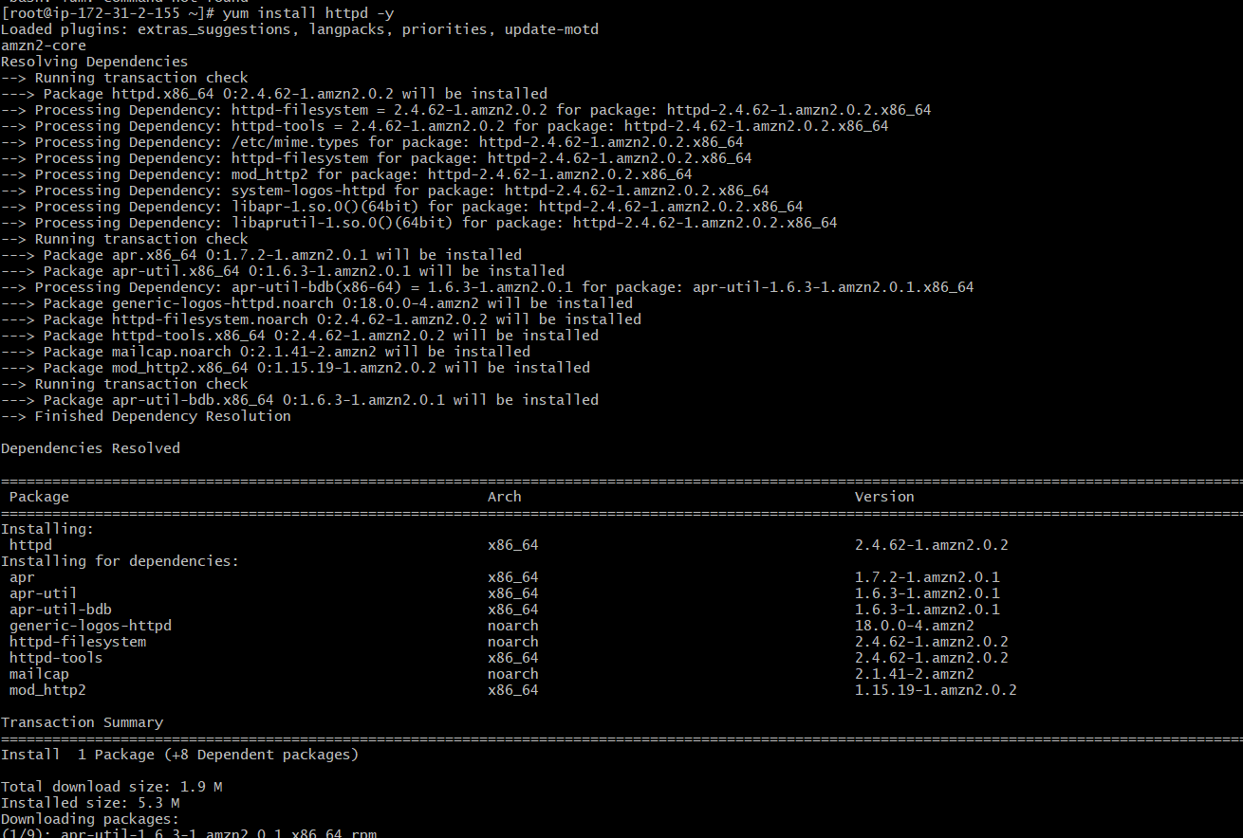  
  
Adding HA proxy server public ip id into /etc/hosts file and used ping command to check connectivity of load balancer.  
  
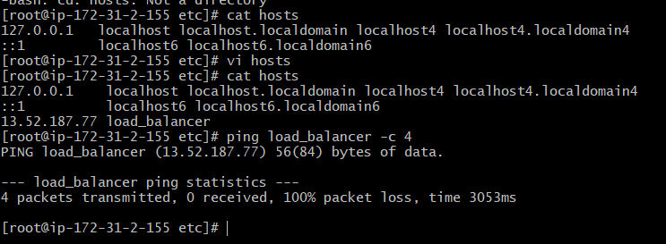

Start the service and check the status.  
  
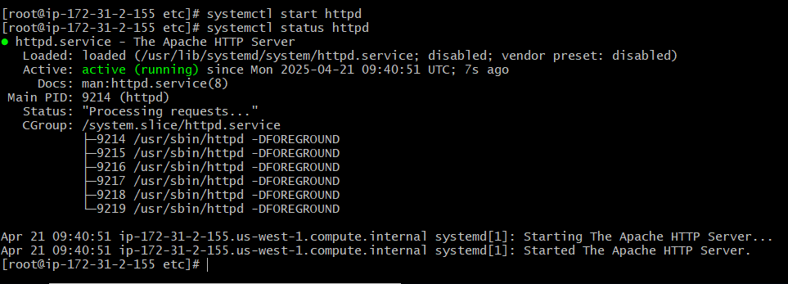

Connected to **server2** in local machine, switching to root user and updating all installed packages  
  
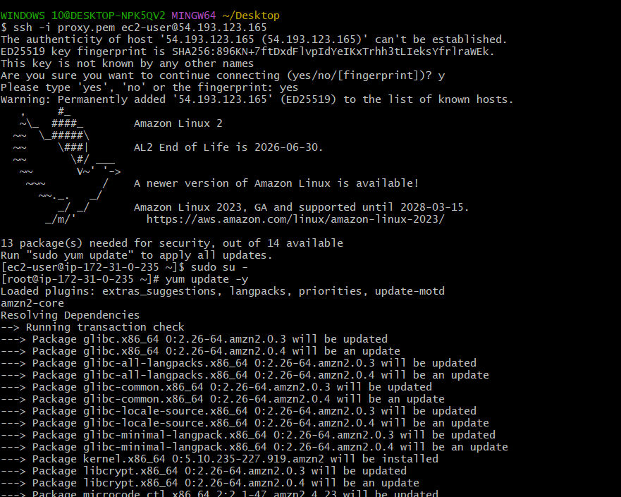

Installing web server nginx

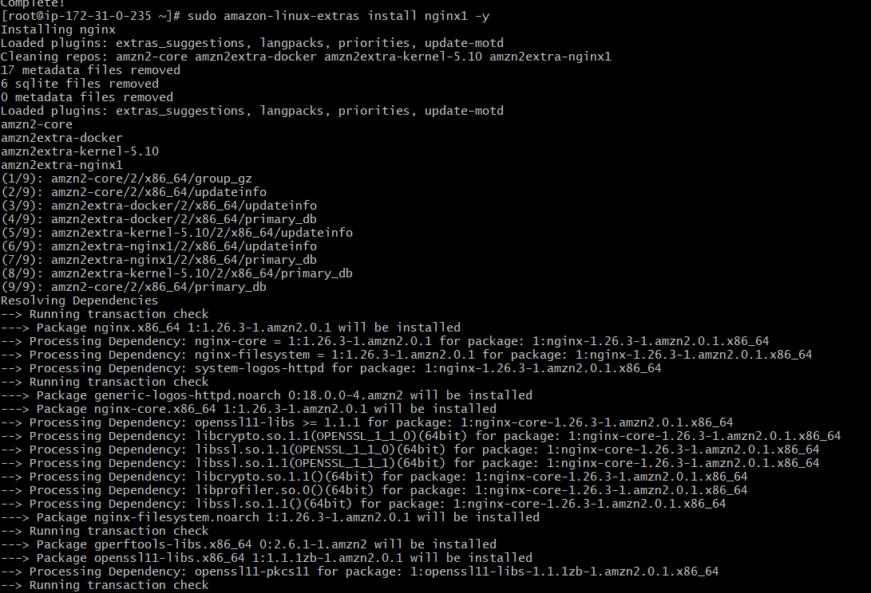  
  
Adding HA proxy server public ip id into /etc/hosts file and used ping command to check connectivity of load balancer.  
  
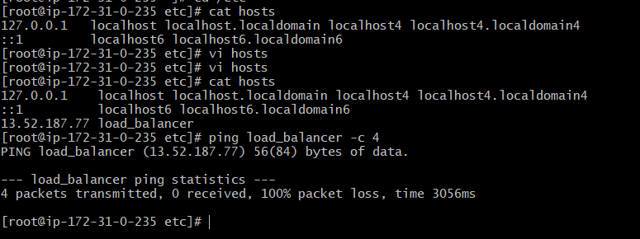

Start the service and check the status.  
  
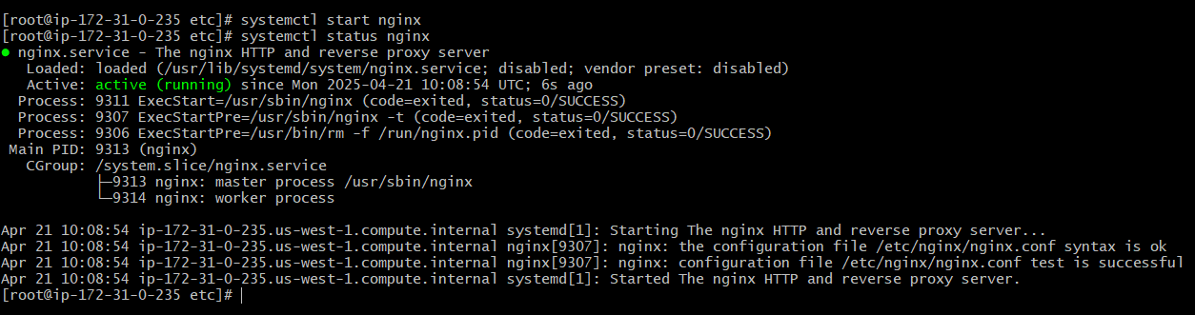  
  
Connected to **Ha proxy server** in local machine, switching to root user and updating all installed packages  
  
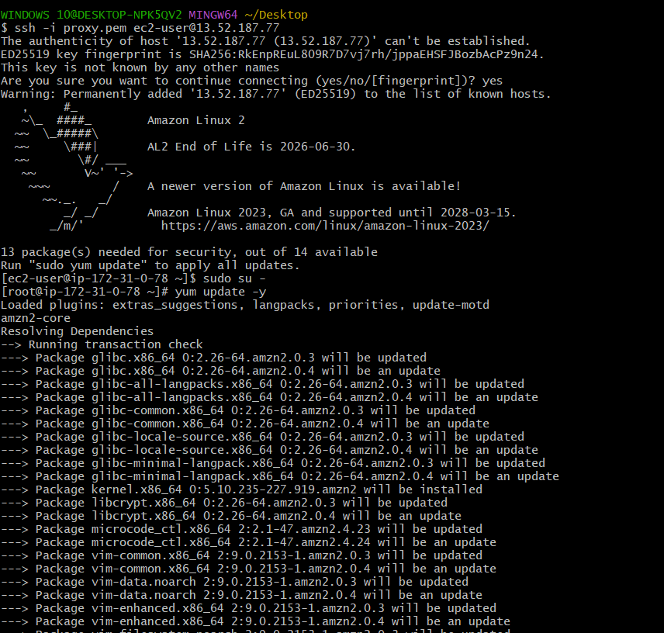  
  
Installing haproxy server  
  
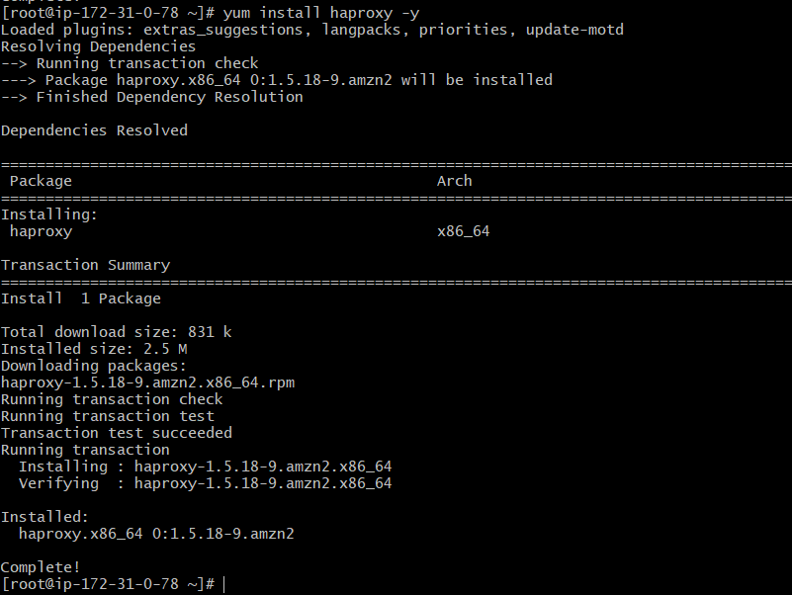  
  
Adding server-1 & server-2 public ip ids into /etc/hosts file and enabling, starting the load balancer.  
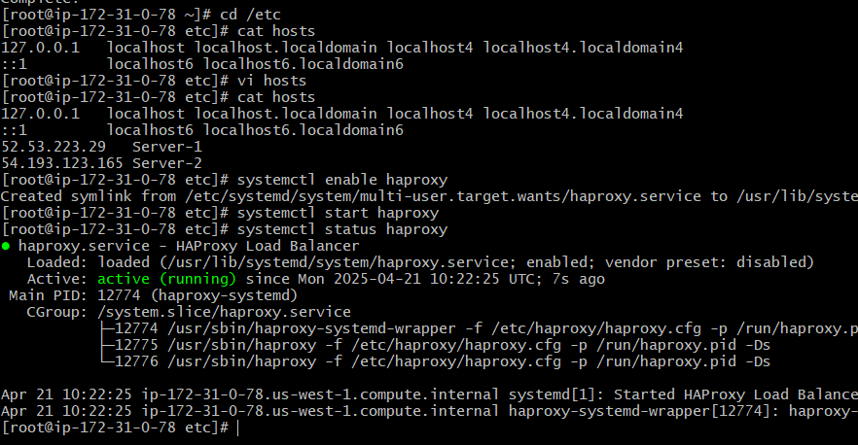  
  
server-1 & 2 both are running on Ha proxy server.  
  
